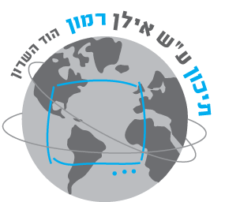

**בית ספר תיכון ע"ש "אילן רמון" הוד השרון**

**Ramon High School – Hod Hasharon**

הכוכבים



**פרויקט גמר**

**"מבוא לתכנות בסביבת האינטרנט"**

**תשפ"ג**

|  |  |
| --- | --- |
| *שם :* | *ירון טרייטל* |
| *ת.ז. :* | *329587240* |
| *כיתה :* | *י'2* |
| *שם המורה :* | *סמדר וכטר* |

# **הקדשה/תודה:**

תודה למורה ולהורי על היעוץ וההכוונה

תודה לאחותי ספיר על העיצוב המשגע

**תוכן עניינים**

הקדשה/תודה: 2

מבוא 4

**תיאור האתר** 4

**האתר ואני** 4

**הפעלת האתר** 4

**מפת האתר** 5

מבנה בסיס הנתונים 6

**שם מסד הנתונים** 6

**שם הטבלה** 6

**שדות הטבלה** 6

קוד האתר 7

**MasterPage** 7

**דפי תוכן (כולל דף הבית)** 20-8

**דף רישום** 20-29

**דף פרופיל אישי** 30-32

**ניהול האתר** 32-34

# **מבוא**

## **תיאור האתר**

באתר מופיע מידע על כל כוכב או כוכב לכת במערכת השמש: שמש, חמה (מרקורי), נוגה (ונוס), כדור הארץ, מאדים, צדק, שבתאי, אורנוס ונפטון. בנוסף מופיע מידע על אסרואידים. כמובן שבכל דף תוכן יש תמונות וכו'.

## **האתר ואני**

בחרתי לבנות אתר זה משום שאני מתעניין בנושא החלל, במהלך העבודה נתקלתי בבעיות שונות כגון חיבור טבלת ה-SQL לאתר, למדתי HTML, Javascript, SQL, CSS, למדתי לעבוד קשה, לחפש באינטרנט עם יש פתרון לבעייה.

## **הפעלת האתר**

לצורך כניסה בתור משתמש/ת )רגיל/ה( רשומ/ה באתר יש למלא את הפרטים הבאים ב Login :

שם משתמש/ת: Sapir

סיסמה: 1234

לצורך כניסה בתור מנהל/ת האתר יש למלא את הפרטים הבאים ב Login :

שם משתמש/ת: admin

סיסמה: 1234

## **מפת האתר**

תרשים זרימה של דפי האתר:

ירוק – משתמש רגיל

אדום - מנהל

# **מבנה בסיס הנתונים**

## **שם מסד הנתונים**

Database.accdb

## **שם הטבלה**

usersTBL

## **שדות הטבלה**

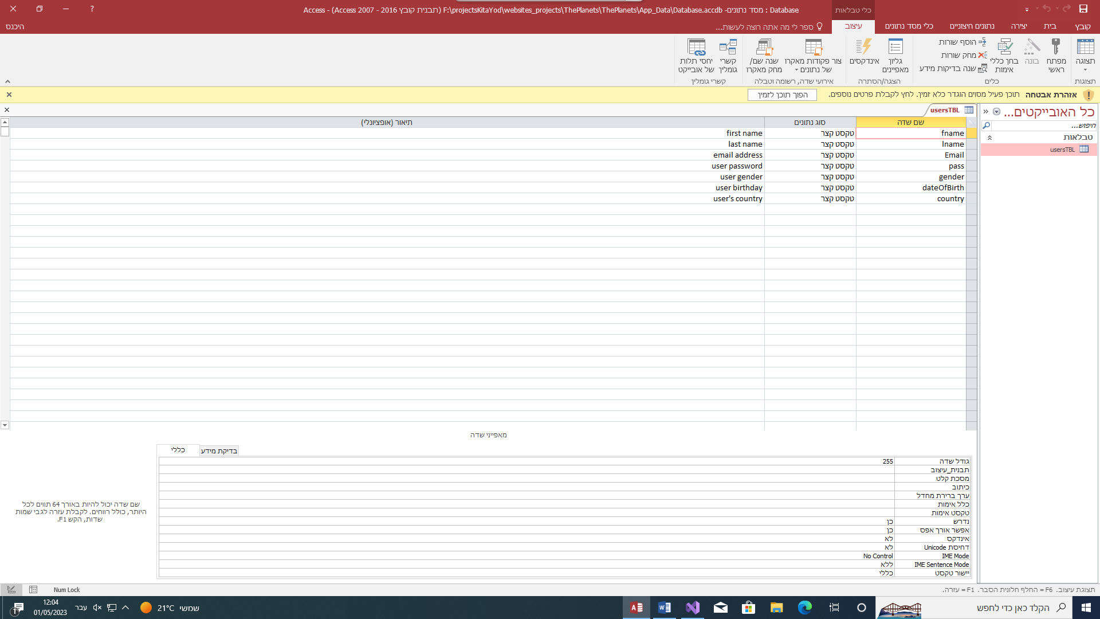

# **קוד האתר**

יש לציין בכל סעיף את שמות הקבצים. אין לצרף צילומי מסך של הקוד אלא את הקוד עצמו.  
על קוד הC# וה-javascript להיות מתועד.

## **MasterPage**

שם הקובץ: Site1.Master

<%@ Master Language="C#" AutoEventWireup="true" CodeBehind="Site1.master.cs" Inherits="ThePlanets.Site1" %>

<!DOCTYPE html>

<html>

<head runat="server">

<link rel="stylesheet" href="style.css">

<link rel="stylesheet" href="https://cdnjs.cloudflare.com/ajax/libs/font-awesome/4.7.0/css/font-awesome.min.css">

<link rel="stylesheet" href="https://cdn.jsdelivr.net/npm/bootstrap-icons@1.3.0/font/bootstrap-icons.css" />

<link rel="icon" type="image/x-icon" href="pics/final.png">

<meta name="viewport" content="width=device-width, initial-scale=1.0">

<asp:ContentPlaceHolder ID="head" runat="server">

</asp:ContentPlaceHolder>

</head>

<body>

<div class="topnav">

<a href="Home.aspx"><i class="fa fa-fw fa-home"></i></a>

<div class="dropdown">

<button class="dropbtn">

planets<i class="fa fa-caret-down"></i>

</button>

<div class="dropdown-content">

<a href="Sun.aspx">Sun</a>

<a href="Mercury.aspx">Mercury</a>

<a href="Venus.aspx">Venus</a>

<a href="Earth.aspx">Earth</a>

<a href="Mars.aspx">Mars</a>

<a href="Jupiter.aspx">Jupiter</a>

<a href="Saturn.aspx">Saturn</a>

<a href="Uranus.aspx">Uranus</a>

<a href="Neptune.aspx">Neptune</a>

</div>

</div>

<div class="dropdown">

<button class="dropbtn">more

<i class="fa fa-caret-down"></i>

</button>

<div class="dropdown-content">

<a href="Astroids.aspx">astroids</a>

<a href="Missions.aspx">missions</a>

<a href="Equipment.aspx">space equipment</a>

</div>

</div>

<% /* If the user is the admin or regular user then the links to their pages (User Page or Admin Page) will appear in the navigator bar */ if (Session["admin"] == null && Session["user"] == null) { %>

<a href="SignUp.aspx">Sign Up</a>

<a href="login.aspx">Log In</a>

<% } %>

<% if (Session["admin"] != null)

{ %>

<a href="AdminPage.aspx"><i class="fa fa-fw fa-user"></i> Admin</a>

<% } %>

<% if (Session["user"] != null)

{%>

<a href="UserPage.aspx"><i class="fa fa-fw fa-user"></i> Profile</a>

<% } %>

</div>

<hr />

<asp:ContentPlaceHolder ID="ContentPlaceHolder1" runat="server">

</asp:ContentPlaceHolder>

</body>

</html>

## **דפי תוכן (כולל דף הבית)**

שם הקובץ: Home.aspx

<%@ Page Title="" Language="C#" MasterPageFile="~/Site1.Master" AutoEventWireup="true" CodeBehind="Home.aspx.cs" Inherits="ThePlanets.Home" %>

<asp:Content ID="Content1" ContentPlaceHolderID="head" runat="server">

<title>Planets | Home</title>

<article class='feature_container' style='background-image: url(&#39;/internal_resources/6057/sshero.jpg&#39;);'>

<link href='https://solarsystem.nasa.gov/internal_resources/6057/sshero.jpg' rel='image_src'>

</article>

</asp:Content>

<asp:Content ID="Content2" ContentPlaceHolderID="ContentPlaceHolder1" runat="server">

<h1>Our Solar System</h1>

<p>The planetary system we call home orbits a star in an outer spiral arm of the vast Milky Way galaxy.</p>

<img style="float: right" src="https://solarsystem.nasa.gov/internal_resources/6057/sshero.jpg" height:520px;

width:100%/>

</asp:Content>

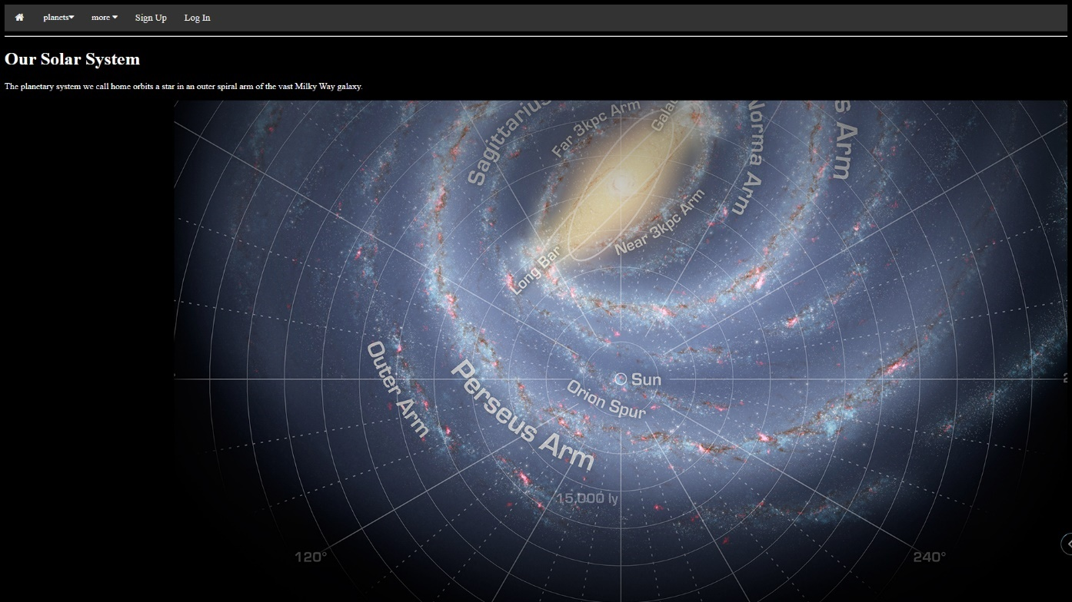

שם הקובץ: Sun.aspx

<%@ Page Title="" Language="C#" MasterPageFile="~/Site1.Master" AutoEventWireup="true" CodeBehind="Sun.aspx.cs" Inherits="ThePlanets.Sun" %>

<asp:Content ID="Content1" ContentPlaceHolderID="head" runat="server">

<title>Planets - Sun</title>

<script type="text/javascript">

/* This functions are changing the pictures in the same place */

function changeSunImg() {

imgSun.src = "pics/structure_sun.png";

}

function changeStructImg() {

imgSun.src = "pics/the-sun.png";

}

</script>

</asp:Content>

<asp:Content ID="Content2" ContentPlaceHolderID="ContentPlaceHolder1" runat="server">

<table class="contentTable">

<tr>

<td><div class="overflow"><img name="imgSun" src="pics/the-sun.png" style="height: 650px;" onmouseover="changeSunImg()" onmouseout="changeStructImg()"/></div></td>

<td>

<table>

<tr><td><p><strong>Sun is the star at the center of the Solar System. It is a nearly perfect ball of hot plasma, heated to incandescence by nuclear fusion reactions in its core. The Sun radiates this energy mainly as light, ultraviolet, and infrared radiation, and is the most important source of energy for life on Earth.</strong></p></td></tr>

<tr>

<td>

<video onloadstart="this.volume=0.03" controls autoplay loop height="400">

<source src="vids/sun-video.mp4" type="video/mp4"/>

<source src="vids/sun-audio.mp3" type="video/mp3"/>

</video>

</td>

</tr>

</table>

</td>

</tr>

</table>

<iframe src="https://solarsystem.nasa.gov/gltf_embed/2352" width="100%" height="450px" frameborder="0" />

</asp:Content>

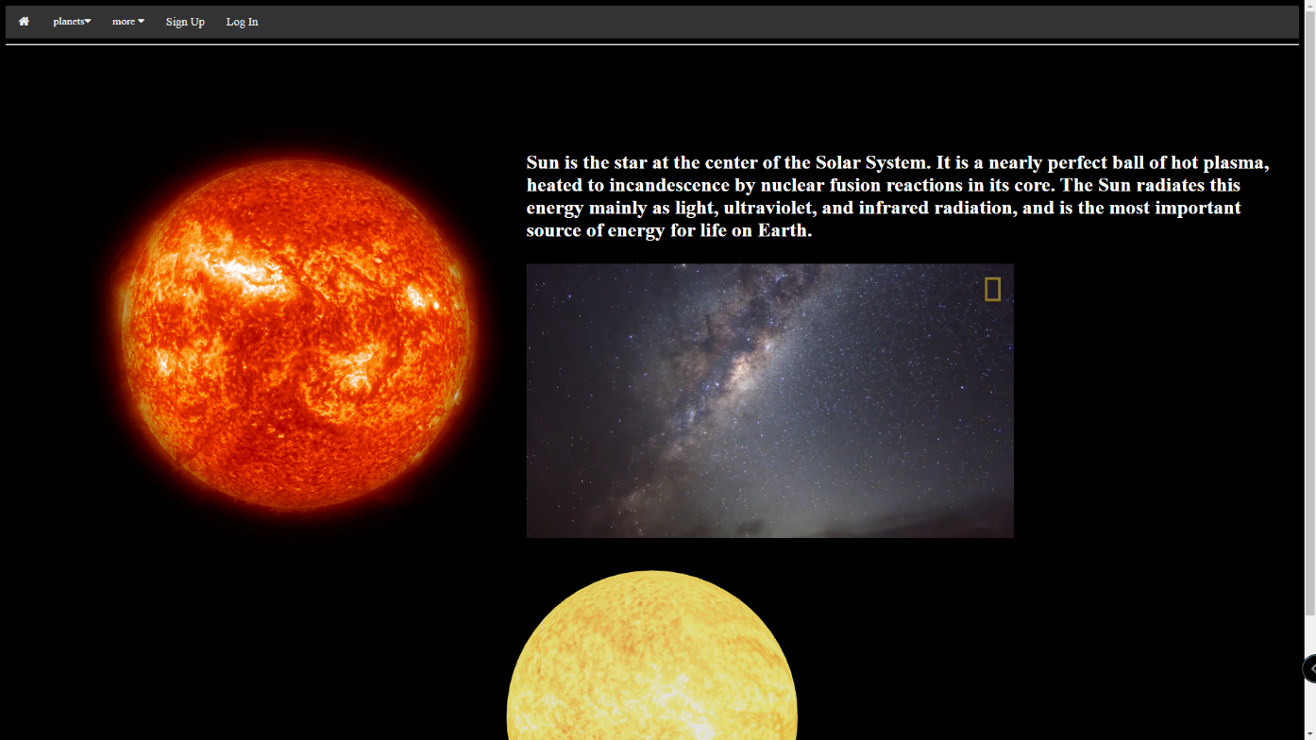

שם הקובץ: Mercury.aspx

<%@ Page Title="" Language="C#" MasterPageFile="~/Site1.Master" AutoEventWireup="true" CodeBehind="Mercury.aspx.cs" Inherits="ThePlanets.Mercury" %>

<asp:Content ID="Content1" ContentPlaceHolderID="head" runat="server">

<title>Planets - Mercury</title>

<script type="text/javascript">

function changeMerImg() {

imgMer.src = "pics/structure_mercury.png";

}

function changeStructImg() {

imgMer.src = "pics/mercury.png";

}

</script>

</asp:Content>

<asp:Content ID="Content2" ContentPlaceHolderID="ContentPlaceHolder1" runat="server">

<br />

<br />

<table class="contentTable">

<tr>

<td><img name="imgMer" src="pics/mercury.png" onmouseover="changeMerImg()" onmouseout="changeStructImg()"/></td>

<td><p>It is the smallest planet in the Solar System, with an equatorial radius of 2,439.7 kilometres (1,516.0 mi). Mercury is also smaller—albeit more massive—than the largest natural satellites in the Solar System, Ganymede and Titan. Mercury consists of approximately 70% metallic and 30% silicate material.</p></td>

</tr>

</table>

<iframe src="https://solarsystem.nasa.gov/gltf_embed/2369" width="100%" height="450px" frameborder="0"/>

</asp:Content>

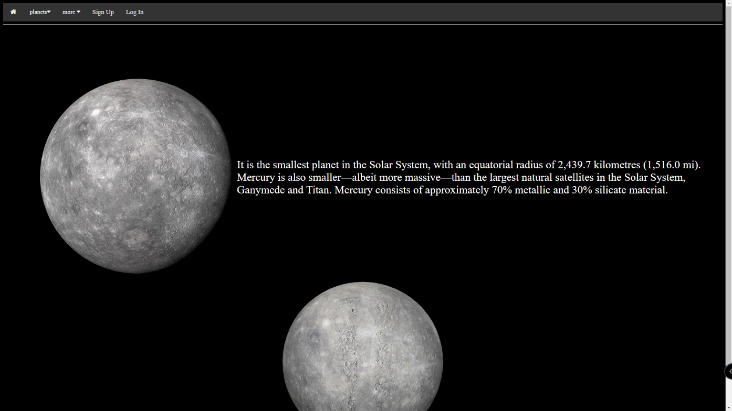

שם קובץ: Venus.aspx

<%@ Page Title="" Language="C#" MasterPageFile="~/Site1.Master" AutoEventWireup="true" CodeBehind="Venus.aspx.cs" Inherits="ThePlanets.Venus" %>

<asp:Content ID="Content1" ContentPlaceHolderID="head" runat="server">

<title>Planets - Venus</title>

<script type="text/javascript">

function changeVenImg() {

imgVen.src = "pics/structure_venus.png";

}

function changeStructImg() {

imgVen.src = "pics/venus.png";

}

</script>

</asp:Content>

<asp:Content ID="Content2" ContentPlaceHolderID="ContentPlaceHolder1" runat="server">

<br />

<br />

<table class="contentTable">

<tr>

<td><img name="imgVen" src="pics/venus.png" onmouseover="changeVenImg()" onmouseout="changeStructImg()"/></td>

<td><p>Venus is the second planet from the Sun and Earth's closest planetary neighbor. Even though Mercury is closer to the Sun, Venus is the hottest planet in our solar system. Its thick atmosphere is full of the greenhouse gas carbon dioxide, and it has clouds of sulfuric acid.</p></td>

</tr>

</table>

<iframe src="https://solarsystem.nasa.gov/gltf_embed/2343" width="100%" height="450px" frameborder="0" />

</asp:Content>

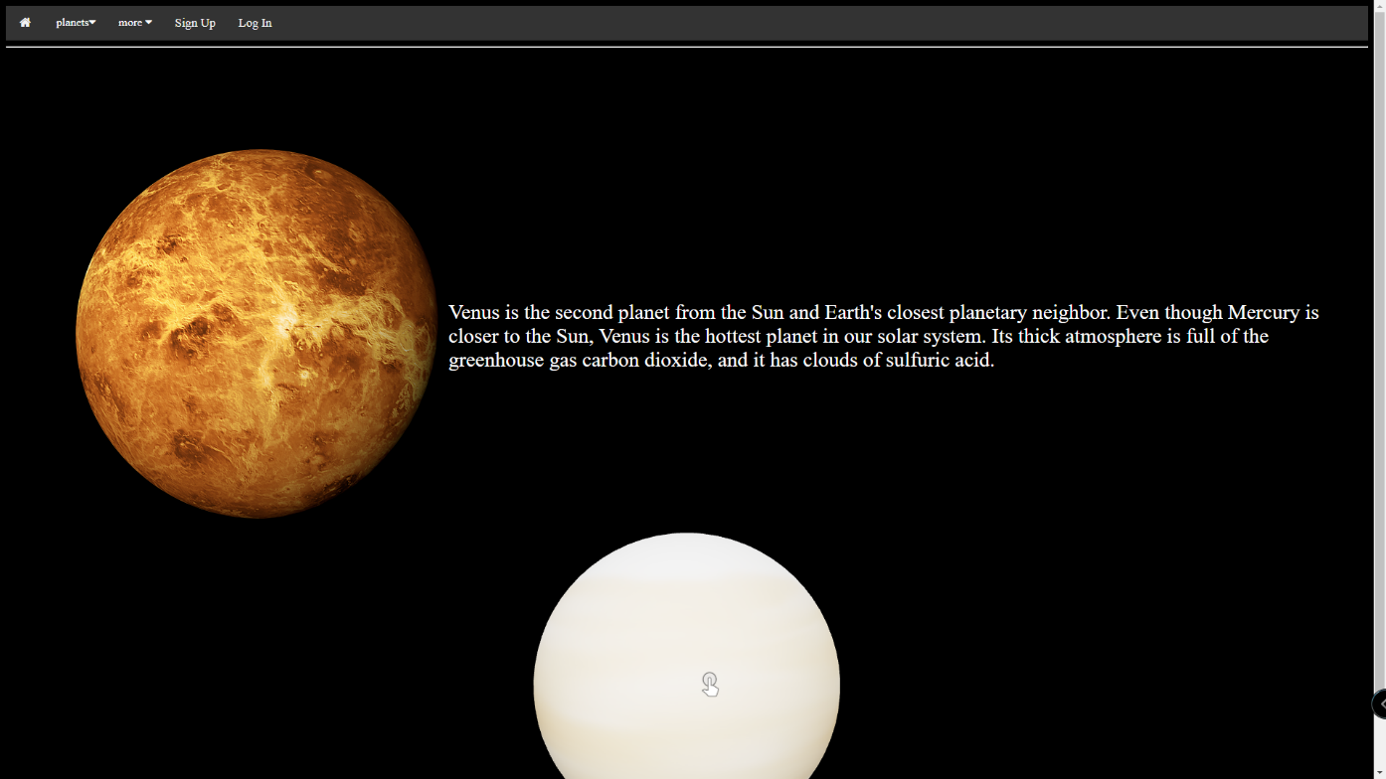

שם קובץ: Earth.aspx

<%@ Page Title="" Language="C#" MasterPageFile="~/Site1.Master" AutoEventWireup="true" CodeBehind="Earth.aspx.cs" Inherits="ThePlanets.Earth" %>

<asp:Content ID="Content1" ContentPlaceHolderID="head" runat="server">

<title>Planets - Earth</title>

</asp:Content>

<asp:Content ID="Content2" ContentPlaceHolderID="ContentPlaceHolder1" runat="server">

<table class="contentTable" cellpading="10" cellspacing="10">

<tr>

<td style="color:white;"><h1><%Response.Write(date);%></h1></td>

</tr>

<tr>

<td><img src="pics/earth-image.png" style="height: 550px;" /></td>

<td>

<table>

<tr><td><p>Earth is an ellipsoid with a circumference of about 40,000 km. It is the densest planet in the Solar System. Of the four rocky planets, it is the largest and most massive. Earth is about eight light minutes away from the Sun and orbits it, taking a year (about 365.25 days) to complete one revolution.</p></td></tr>

<tr>

<td>

<iframe width="900" height="330" src="https://www.youtube.com/embed/86YLFOog4GM?autoplay=1&mute=1&controls=0" title="YouTube video player" frameborder="0" allow="accelerometer; autoplay; clipboard-write; encrypted-media; gyroscope; picture-in-picture; web-share" allowfullscreen></iframe>

</td>

</tr>

</table>

</td>

</tr>

</table>

<iframe src="https://solarsystem.nasa.gov/gltf_embed/2392/" width="100%" height="450px" frameborder="0"/>

</asp:Content>

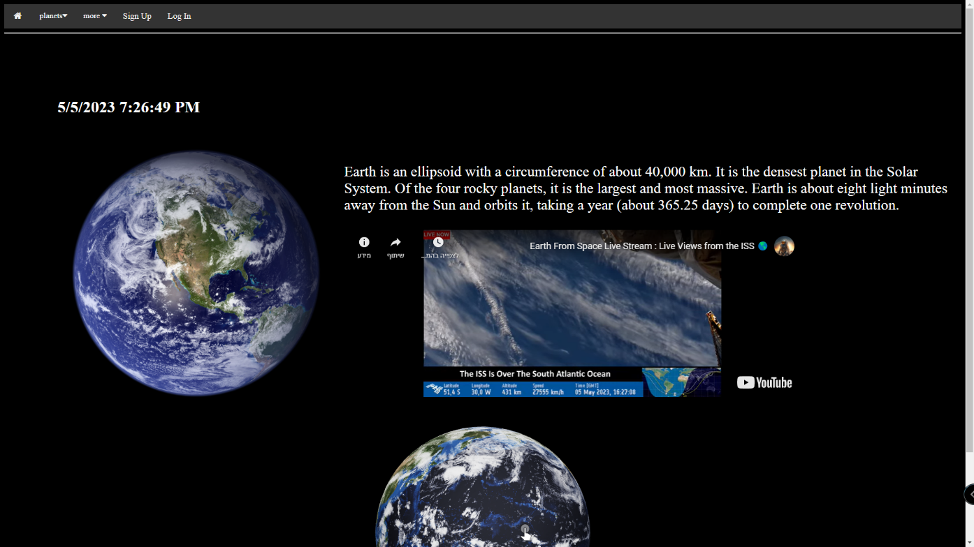

שם קובץ: Mars.aspx

<%@ Page Title="" Language="C#" MasterPageFile="~/Site1.Master" AutoEventWireup="true" CodeBehind="Mars.aspx.cs" Inherits="ThePlanets.Mars" %>

<asp:Content ID="Content1" ContentPlaceHolderID="head" runat="server">

<title>Planets - Mars</title>

</asp:Content>

<asp:Content ID="Content2" ContentPlaceHolderID="ContentPlaceHolder1" runat="server">

<br />

<br />

<table class="contentTable">

<tr>

<td><img src="pics/mars.png"/></td>

<td><p>​Mars is the fourth planet from the Sun – a dusty, cold, desert world with a very thin atmosphere. Mars is also a dynamic planet with seasons, polar ice caps, canyons, extinct volcanoes, and evidence that it was even more active in the past.</p></td>

</tr>

</table>

<iframe src="https://mars.nasa.gov/gltf_embed/24881" width="100%" height="450px" frameborder="0" />

</asp:Content>

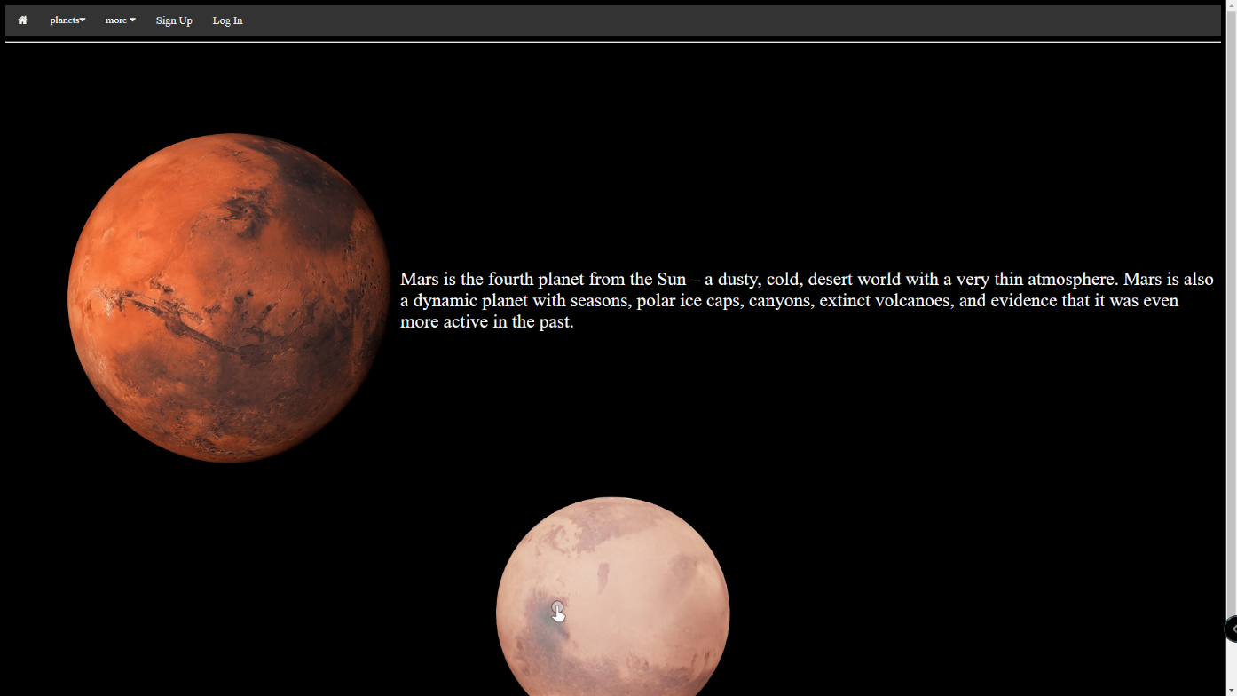

שם קובץ: Jupiter.aspx

<%@ Page Title="" Language="C#" MasterPageFile="~/Site1.Master" AutoEventWireup="true" CodeBehind="Jupiter.aspx.cs" Inherits="ThePlanets.Jupiter" %>

<asp:Content ID="Content1" ContentPlaceHolderID="head" runat="server">

<title>Planets - Jupiter</title>

</asp:Content>

<asp:Content ID="Content2" ContentPlaceHolderID="ContentPlaceHolder1" runat="server">

<br />

<br />

<table class="contentTable">

<tr>

<td><img src="pics/jupiter.png"/></td>

<td><p>Jupiter is the fifth planet from our Sun and is, by far, the largest planet in the solar system – more than twice as massive as all the other planets combined. Jupiter's stripes and swirls are actually cold, windy clouds of ammonia and water, floating in an atmosphere of hydrogen and helium.</p></td>

</tr>

</table>

<iframe src="https://solarsystem.nasa.gov/gltf_embed/2375" width="100%" height="450px" frameborder="0" />

</asp:Content>

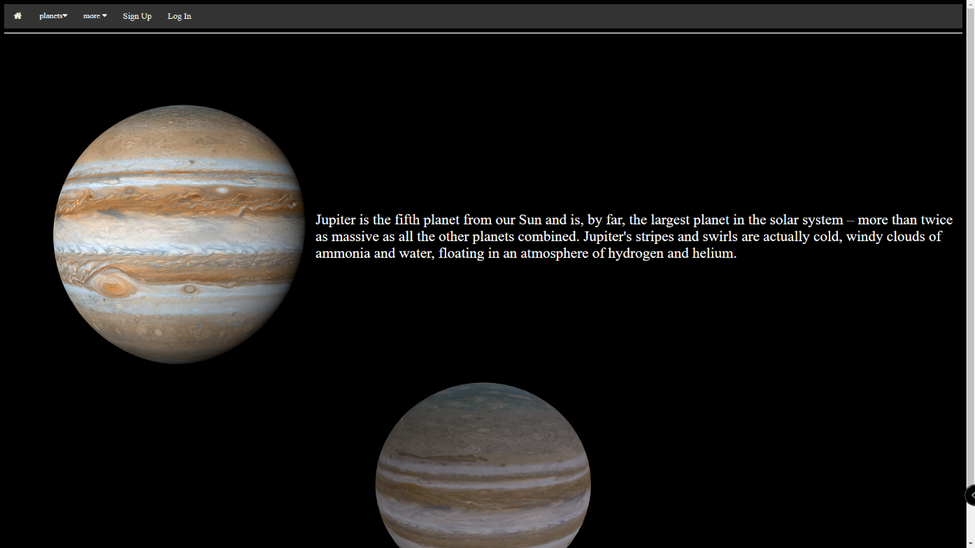

## 

שם קובץ: Saturn.aspx

<%@ Page Title="" Language="C#" MasterPageFile="~/Site1.Master" AutoEventWireup="true" CodeBehind="Saturn.aspx.cs" Inherits="ThePlanets.Saturn" %>

<asp:Content ID="Content1" ContentPlaceHolderID="head" runat="server">

<title>Planets - Saturn</title>

</asp:Content>

<asp:Content ID="Content2" ContentPlaceHolderID="ContentPlaceHolder1" runat="server">

<table class="contentTable">

<tr>

<td><img src="pics/saturn.png" style="height: 550px;"/></td>

<td><p>Saturn is the sixth planet from the Sun and the second-largest planet in our solar system. Like fellow gas giant Jupiter, Saturn is a massive ball made mostly of hydrogen and helium. Saturn is not the only planet to have rings, but none are as spectacular or as complex as Saturn's. Saturn also has dozens of moons.</p></td>

</tr>

</table>

<iframe src="https://solarsystem.nasa.gov/gltf_embed/2355" width="100%" height="450px" frameborder="0"/>

</asp:Content>

ad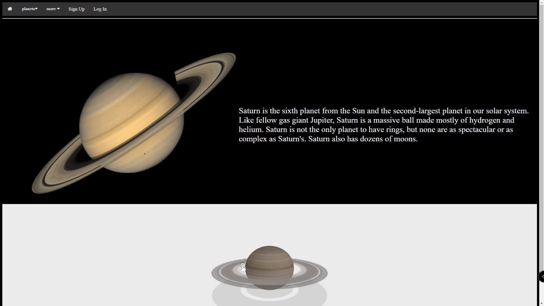

## שם קובץ: Uranus.aspx

<%@ Page Title="" Language="C#" MasterPageFile="~/Site1.Master" AutoEventWireup="true" CodeBehind="Uranus.aspx.cs" Inherits="ThePlanets.Uranus" %>

<asp:Content ID="Content1" ContentPlaceHolderID="head" runat="server">

<title>Planets - Uranus</title>

</asp:Content>

<asp:Content ID="Content2" ContentPlaceHolderID="ContentPlaceHolder1" runat="server">

<br />

<table class="contentTable">

<tr>

<td><img src="pics/uranus.jpg" style="height: 550px;" /></td>

<td><p>Uranus is the seventh planet from the Sun, and has the third-largest diameter in our solar system. It was the first planet found with the aid of a telescope, Uranus was discovered in 1781 by astronomer William Herschel, although he originally thought it was either a comet or a star.</p></td>

</tr>

</table>

<iframe src="https://solarsystem.nasa.gov/gltf_embed/2344" width="100%" height="450px" frameborder="0" />

</asp:Content>

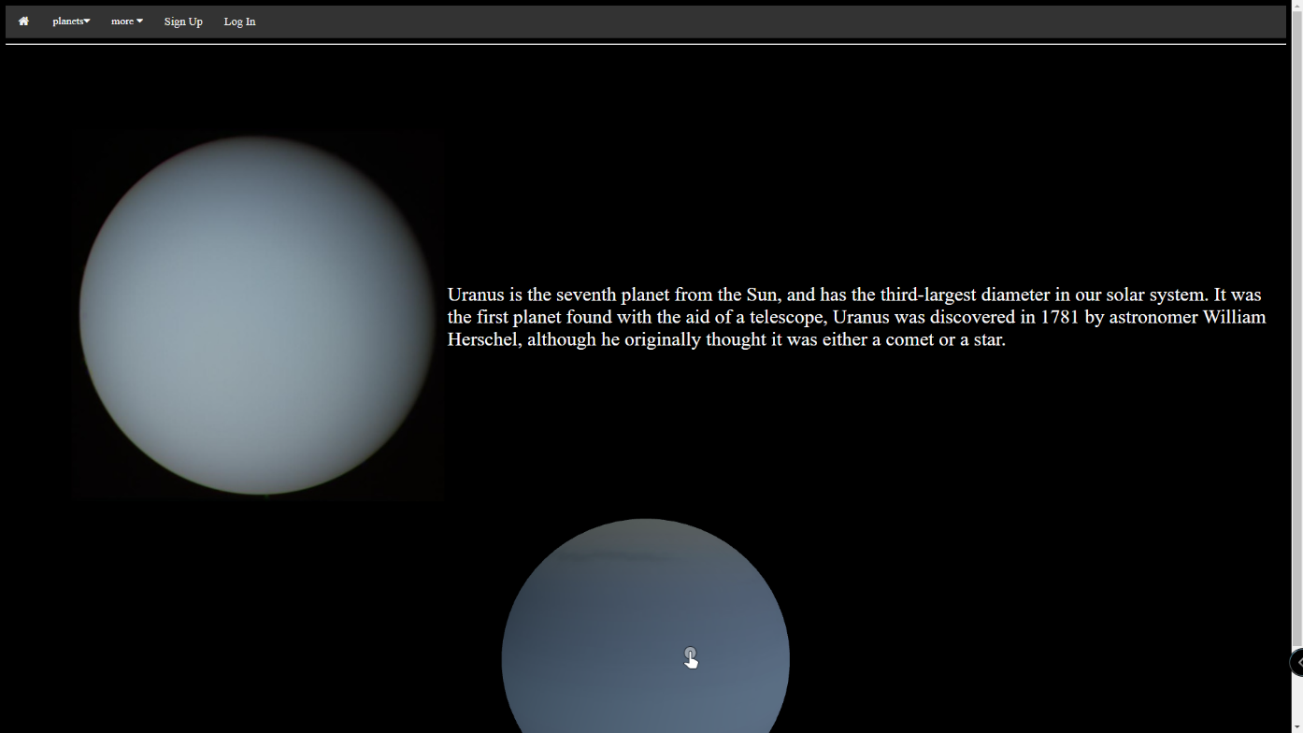

## שם קובץ: Neptune.aspx

<%@ Page Title="" Language="C#" MasterPageFile="~/Site1.Master" AutoEventWireup="true" CodeBehind="Neptune.aspx.cs" Inherits="ThePlanets.Neptune" %>

<asp:Content ID="Content1" ContentPlaceHolderID="head" runat="server">

<title>Planets - Neptune</title>

</asp:Content>

<asp:Content ID="Content2" ContentPlaceHolderID="ContentPlaceHolder1" runat="server">

<table class="contentTable">

<tr>

<td><img src="pics/neptune.jpg" style="height: 550px;"/></td>

<td><p>It's made of a thick soup of water, ammonia, and methane over an Earth-sized solid center. Its atmosphere is made of hydrogen, helium, and methane. The methane gives Neptune the same blue color as Uranus. Neptune has six rings, but they're very hard to see.</p></td>

</tr>

</table>

<iframe src="https://solarsystem.nasa.gov/gltf_embed/2364" width="100%" height="450px" frameborder="0" />

</asp:Content>

## 

## **שם קובץ: Astroids.aspx**

<%@ Page Title="" Language="C#" MasterPageFile="~/Site1.Master" AutoEventWireup="true" CodeBehind="Astroids.aspx.cs" Inherits="ThePlanets.Astroids" %>

<asp:Content ID="Content1" ContentPlaceHolderID="head" runat="server">

<title>Astroids</title>

</asp:Content>

<asp:Content ID="Content2" ContentPlaceHolderID="ContentPlaceHolder1" runat="server">

<table class="contentTable">

<tr>

<td><img src="https://www.spacereference.org/static/images/generic-asteroid.png"/></td>

<td><iframe src="https://solarsystem.nasa.gov/gltf_embed/2403" width="1340px" height="700px" frameborder="0"></iframe></td>

</tr>

</table>

</asp:Content>

## 

## **שם קובץ: Equipment.aspx**

<%@ Page Title="" Language="C#" MasterPageFile="~/Site1.Master" AutoEventWireup="true" CodeBehind="Equipment.aspx.cs" Inherits="ThePlanets.Equipment" %>

<asp:Content ID="Content1" ContentPlaceHolderID="head" runat="server">

<title>Space Equipment</title>

</asp:Content>

<asp:Content ID="Content2" ContentPlaceHolderID="ContentPlaceHolder1" runat="server">

<h2>Deep Space Network 35 Meter Antenna</h2>

<iframe src="https://solarsystem.nasa.gov/gltf_embed/2395" width="45%" height="450px" frameborder="0"></iframe>

<h2>NASA's Juno Jupiter orbiter</h2>

<iframe src="https://solarsystem.nasa.gov/gltf_embed/2376" width="45%" height="450px" frameborder="0"></iframe>

<h2>Curiosity Mars rover</h2>

<iframe src="https://solarsystem.nasa.gov/gltf_embed/2398" width="45%" height="450px" frameborder="0"></iframe>

<h2>MAVEN Mars orbiter</h2>

<iframe src="https://solarsystem.nasa.gov/gltf_embed/2371" width="45%" height="450px" frameborder="0"></iframe>

</asp:Content>

## 

## דף התוכן האחרון הוא משני ולכן לא ציינתי אותו. (שם קובץ: Missions.aspx)

## **דף רישום**

שם קובץ: Sign.aspx

Aspx code:

**<%@ Page Title="" Language="C#" MasterPageFile="~/Site1.Master" AutoEventWireup="true" CodeBehind="SignUp.aspx.cs" Inherits="ThePlanets.SignUp" %>**

**<asp:Content ID="Content1" ContentPlaceHolderID="head" runat="server">**

**<title>Sign Up</title>**

**<script type="text/javascript">**

**function check() {**

**if (signUpForm.fname.value == 0 || signUpForm.fname.value.length > 8) {**

**if (signUpForm.fname.value.lenght == 0) {**

**alert("You haven't written your first name.");**

**signUpForm.fname.focus();**

**return false;**

**} else if (signUpForm.fname.value.lenght > 8) {**

**alert("Your first name can't be over 8 characters.");**

**signUpForm.fname.focus();**

**return false;**

**}**

**} else {**

**return true;**

**}**

**if (signUpForm.fname.value.lenght == 0 || signUpForm.fname.value.length > 8) {**

**if (signUpForm.fname.value.lenght == 0) {**

**alert("You haven't written your first name.");**

**signUpForm.fname.focus();**

**return false;**

**} else if (signUpForm.fname.value.lenght > 8) {**

**alert("Your first name can't be over 8 characters.");**

**signUpForm.fname.focus();**

**return false;**

**}**

**} else {**

**return true;**

**}**

**if (signUpForm.fname.value.lenght == 0 || signUpForm.fname.value.length > 8) {**

**if (signUpForm.fname.value.lenght == 0) {**

**alert("You haven't written your first name.");**

**signUpForm.fname.focus();**

**return false;**

**} else if (signUpForm.fname.value.lenght > 8) {**

**alert("Your first name can't be over 8 characters.");**

**signUpForm.fname.focus();**

**return false;**

**}**

**} else {**

**return true;**

**}**

**}**

**</script>**

**</asp:Content>**

**<asp:Content ID="Content2" ContentPlaceHolderID="ContentPlaceHolder1" runat="server">**

**<h1><% Response.Write(RegStatus); %> </h1>**

**<% if (Session["user"] == null && Session["admin"] == null)**

**{ %>**

**<form name="signUpForm" action="SignUp.aspx" method="post">**

**<div>**

**<p>Please fill in this form to create an account.</p>**

**<br />**

**<br />**

**<label for="fname"><b>First Name</b></label>**

**<input type="text" placeholder="First Name" name="fname" id="fname" minlength="3" maxlength="10" required/>**

**<br />**

**<br />**

**<label for="lname"><b>Last Name</b></label>**

**<input type="text" placeholder="Last Name" name="lname" id="lname" minlength="3" maxlength="10" required/>**

**<br />**

**<br />**

**<label for="Email"><b>Email</b></label>**

**<input type="text" placeholder="Enter Email" name="Email" id="Email" minlength="15" maxlength="25" required/>**

**<br />**

**<br />**

**<label for="psw"><b>Password</b></label>**

**<input type="password" placeholder="Enter Password" name="psw" id="psw" minlength="4" maxlength="16" required/>**

**<i class="bi bi-eye-slash" id="togglePassword"></i>**

**<br />**

**<br />**

**<label for="gender">**

**Gender :**

**</label><br>**

**<input type="radio" name="gender" value="male" required> Male**

**<input type="radio" name="gender" value="female" required> Female**

**<input type="radio" name="gender" value="other" required/> Other**

**<br />**

**<br />**

**<label for="coun">Country</label>**

**<select id="coun" name="coun" class="form-control" required>**

**<option value="Afghanistan">Afghanistan</option>**

**<option value="Åland Islands">Åland Islands</option>**

**<option value="Albania">Albania</option>**

**<option value="Algeria">Algeria</option>**

**<option value="American Samoa">American Samoa</option>**

**<option value="Andorra">Andorra</option>**

**<option value="Angola">Angola</option>**

**<option value="Anguilla">Anguilla</option>**

**<option value="Antarctica">Antarctica</option>**

**<option value="Antigua and Barbuda">Antigua and Barbuda</option>**

**<option value="Argentina">Argentina</option>**

**<option value="Armenia">Armenia</option>**

**<option value="Aruba">Aruba</option>**

**<option value="Australia">Australia</option>**

**<option value="Austria">Austria</option>**

**<option value="Azerbaijan">Azerbaijan</option>**

**<option value="Bahamas">Bahamas</option>**

**<option value="Bahrain">Bahrain</option>**

**<option value="Bangladesh">Bangladesh</option>**

**<option value="Barbados">Barbados</option>**

**<option value="Belarus">Belarus</option>**

**<option value="Belgium">Belgium</option>**

**<option value="Belize">Belize</option>**

**<option value="Benin">Benin</option>**

**<option value="Bermuda">Bermuda</option>**

**<option value="Bhutan">Bhutan</option>**

**<option value="Bolivia">Bolivia</option>**

**<option value="Bosnia and Herzegovina">Bosnia and Herzegovina</option>**

**<option value="Botswana">Botswana</option>**

**<option value="Bouvet Island">Bouvet Island</option>**

**<option value="Brazil">Brazil</option>**

**<option value="British Indian Ocean Territory">British Indian Ocean Territory</option>**

**<option value="Brunei Darussalam">Brunei Darussalam</option>**

**<option value="Bulgaria">Bulgaria</option>**

**<option value="Burkina Faso">Burkina Faso</option>**

**<option value="Burundi">Burundi</option>**

**<option value="Cambodia">Cambodia</option>**

**<option value="Cameroon">Cameroon</option>**

**<option value="Canada">Canada</option>**

**<option value="Cape Verde">Cape Verde</option>**

**<option value="Cayman Islands">Cayman Islands</option>**

**<option value="Central African Republic">Central African Republic</option>**

**<option value="Chad">Chad</option>**

**<option value="Chile">Chile</option>**

**<option value="China">China</option>**

**<option value="Christmas Island">Christmas Island</option>**

**<option value="Cocos (Keeling) Islands">Cocos (Keeling) Islands</option>**

**<option value="Colombia">Colombia</option>**

**<option value="Comoros">Comoros</option>**

**<option value="Congo">Congo</option>**

**<option value="Congo, The Democratic Republic of The">Congo, The Democratic Republic of The</option>**

**<option value="Cook Islands">Cook Islands</option>**

**<option value="Costa Rica">Costa Rica</option>**

**<option value="Cote D'ivoire">Cote D'ivoire</option>**

**<option value="Croatia">Croatia</option>**

**<option value="Cuba">Cuba</option>**

**<option value="Cyprus">Cyprus</option>**

**<option value="Czech Republic">Czech Republic</option>**

**<option value="Denmark">Denmark</option>**

**<option value="Djibouti">Djibouti</option>**

**<option value="Dominica">Dominica</option>**

**<option value="Dominican Republic">Dominican Republic</option>**

**<option value="Ecuador">Ecuador</option>**

**<option value="Egypt">Egypt</option>**

**<option value="El Salvador">El Salvador</option>**

**<option value="Equatorial Guinea">Equatorial Guinea</option>**

**<option value="Eritrea">Eritrea</option>**

**<option value="Estonia">Estonia</option>**

**<option value="Ethiopia">Ethiopia</option>**

**<option value="Falkland Islands (Malvinas)">Falkland Islands (Malvinas)</option>**

**<option value="Faroe Islands">Faroe Islands</option>**

**<option value="Fiji">Fiji</option>**

**<option value="Finland">Finland</option>**

**<option value="France">France</option>**

**<option value="French Guiana">French Guiana</option>**

**<option value="French Polynesia">French Polynesia</option>**

**<option value="French Southern Territories">French Southern Territories</option>**

**<option value="Gabon">Gabon</option>**

**<option value="Gambia">Gambia</option>**

**<option value="Georgia">Georgia</option>**

**<option value="Germany">Germany</option>**

**<option value="Ghana">Ghana</option>**

**<option value="Gibraltar">Gibraltar</option>**

**<option value="Greece">Greece</option>**

**<option value="Greenland">Greenland</option>**

**<option value="Grenada">Grenada</option>**

**<option value="Guadeloupe">Guadeloupe</option>**

**<option value="Guam">Guam</option>**

**<option value="Guatemala">Guatemala</option>**

**<option value="Guernsey">Guernsey</option>**

**<option value="Guinea">Guinea</option>**

**<option value="Guinea-bissau">Guinea-bissau</option>**

**<option value="Guyana">Guyana</option>**

**<option value="Haiti">Haiti</option>**

**<option value="Heard Island and Mcdonald Islands">Heard Island and Mcdonald Islands</option>**

**<option value="Holy See (Vatican City State)">Holy See (Vatican City State)</option>**

**<option value="Honduras">Honduras</option>**

**<option value="Hong Kong">Hong Kong</option>**

**<option value="Hungary">Hungary</option>**

**<option value="Iceland">Iceland</option>**

**<option value="India">India</option>**

**<option value="Indonesia">Indonesia</option>**

**<option value="Iran, Islamic Republic of">Iran, Islamic Republic of</option>**

**<option value="Iraq">Iraq</option>**

**<option value="Ireland">Ireland</option>**

**<option value="Isle of Man">Isle of Man</option>**

**<option value="Israel">Israel</option>**

**<option value="Italy">Italy</option>**

**<option value="Jamaica">Jamaica</option>**

**<option value="Japan">Japan</option>**

**<option value="Jersey">Jersey</option>**

**<option value="Jordan">Jordan</option>**

**<option value="Kazakhstan">Kazakhstan</option>**

**<option value="Kenya">Kenya</option>**

**<option value="Kiribati">Kiribati</option>**

**<option value="Korea, Democratic People's Republic of">Korea, Democratic People's Republic of</option>**

**<option value="Korea, Republic of">Korea, Republic of</option>**

**<option value="Kuwait">Kuwait</option>**

**<option value="Kyrgyzstan">Kyrgyzstan</option>**

**<option value="Lao People's Democratic Republic">Lao People's Democratic Republic</option>**

**<option value="Latvia">Latvia</option>**

**<option value="Lebanon">Lebanon</option>**

**<option value="Lesotho">Lesotho</option>**

**<option value="Liberia">Liberia</option>**

**<option value="Libyan Arab Jamahiriya">Libyan Arab Jamahiriya</option>**

**<option value="Liechtenstein">Liechtenstein</option>**

**<option value="Lithuania">Lithuania</option>**

**<option value="Luxembourg">Luxembourg</option>**

**<option value="Macao">Macao</option>**

**<option value="Macedonia, The Former Yugoslav Republic of">Macedonia, The Former Yugoslav Republic of</option>**

**<option value="Madagascar">Madagascar</option>**

**<option value="Malawi">Malawi</option>**

**<option value="Malaysia">Malaysia</option>**

**<option value="Maldives">Maldives</option>**

**<option value="Mali">Mali</option>**

**<option value="Malta">Malta</option>**

**<option value="Marshall Islands">Marshall Islands</option>**

**<option value="Martinique">Martinique</option>**

**<option value="Mauritania">Mauritania</option>**

**<option value="Mauritius">Mauritius</option>**

**<option value="Mayotte">Mayotte</option>**

**<option value="Mexico">Mexico</option>**

**<option value="Micronesia, Federated States of">Micronesia, Federated States of</option>**

**<option value="Moldova, Republic of">Moldova, Republic of</option>**

**<option value="Monaco">Monaco</option>**

**<option value="Mongolia">Mongolia</option>**

**<option value="Montenegro">Montenegro</option>**

**<option value="Montserrat">Montserrat</option>**

**<option value="Morocco">Morocco</option>**

**<option value="Mozambique">Mozambique</option>**

**<option value="Myanmar">Myanmar</option>**

**<option value="Namibia">Namibia</option>**

**<option value="Nauru">Nauru</option>**

**<option value="Nepal">Nepal</option>**

**<option value="Netherlands">Netherlands</option>**

**<option value="Netherlands Antilles">Netherlands Antilles</option>**

**<option value="New Caledonia">New Caledonia</option>**

**<option value="New Zealand">New Zealand</option>**

**<option value="Nicaragua">Nicaragua</option>**

**<option value="Niger">Niger</option>**

**<option value="Nigeria">Nigeria</option>**

**<option value="Niue">Niue</option>**

**<option value="Norfolk Island">Norfolk Island</option>**

**<option value="Northern Mariana Islands">Northern Mariana Islands</option>**

**<option value="Norway">Norway</option>**

**<option value="Oman">Oman</option>**

**<option value="Pakistan">Pakistan</option>**

**<option value="Palau">Palau</option>**

**<option value="Palestinian Territory, Occupied">Palestinian Territory, Occupied</option>**

**<option value="Panama">Panama</option>**

**<option value="Papua New Guinea">Papua New Guinea</option>**

**<option value="Paraguay">Paraguay</option>**

**<option value="Peru">Peru</option>**

**<option value="Philippines">Philippines</option>**

**<option value="Pitcairn">Pitcairn</option>**

**<option value="Poland">Poland</option>**

**<option value="Portugal">Portugal</option>**

**<option value="Puerto Rico">Puerto Rico</option>**

**<option value="Qatar">Qatar</option>**

**<option value="Reunion">Reunion</option>**

**<option value="Romania">Romania</option>**

**<option value="Russian Federation">Russian Federation</option>**

**<option value="Rwanda">Rwanda</option>**

**<option value="Saint Helena">Saint Helena</option>**

**<option value="Saint Kitts and Nevis">Saint Kitts and Nevis</option>**

**<option value="Saint Lucia">Saint Lucia</option>**

**<option value="Saint Pierre and Miquelon">Saint Pierre and Miquelon</option>**

**<option value="Saint Vincent and The Grenadines">Saint Vincent and The Grenadines</option>**

**<option value="Samoa">Samoa</option>**

**<option value="San Marino">San Marino</option>**

**<option value="Sao Tome and Principe">Sao Tome and Principe</option>**

**<option value="Saudi Arabia">Saudi Arabia</option>**

**<option value="Senegal">Senegal</option>**

**<option value="Serbia">Serbia</option>**

**<option value="Seychelles">Seychelles</option>**

**<option value="Sierra Leone">Sierra Leone</option>**

**<option value="Singapore">Singapore</option>**

**<option value="Slovakia">Slovakia</option>**

**<option value="Slovenia">Slovenia</option>**

**<option value="Solomon Islands">Solomon Islands</option>**

**<option value="Somalia">Somalia</option>**

**<option value="South Africa">South Africa</option>**

**<option value="South Georgia and The South Sandwich Islands">South Georgia and The South Sandwich Islands</option>**

**<option value="Spain">Spain</option>**

**<option value="Sri Lanka">Sri Lanka</option>**

**<option value="Sudan">Sudan</option>**

**<option value="Suriname">Suriname</option>**

**<option value="Svalbard and Jan Mayen">Svalbard and Jan Mayen</option>**

**<option value="Swaziland">Swaziland</option>**

**<option value="Sweden">Sweden</option>**

**<option value="Switzerland">Switzerland</option>**

**<option value="Syrian Arab Republic">Syrian Arab Republic</option>**

**<option value="Taiwan">Taiwan</option>**

**<option value="Tajikistan">Tajikistan</option>**

**<option value="Tanzania, United Republic of">Tanzania, United Republic of</option>**

**<option value="Thailand">Thailand</option>**

**<option value="Timor-leste">Timor-leste</option>**

**<option value="Togo">Togo</option>**

**<option value="Tokelau">Tokelau</option>**

**<option value="Tonga">Tonga</option>**

**<option value="Trinidad and Tobago">Trinidad and Tobago</option>**

**<option value="Tunisia">Tunisia</option>**

**<option value="Turkey">Turkey</option>**

**<option value="Turkmenistan">Turkmenistan</option>**

**<option value="Turks and Caicos Islands">Turks and Caicos Islands</option>**

**<option value="Tuvalu">Tuvalu</option>**

**<option value="Uganda">Uganda</option>**

**<option value="Ukraine">Ukraine</option>**

**<option value="United Arab Emirates">United Arab Emirates</option>**

**<option value="United Kingdom">United Kingdom</option>**

**<option value="United States">United States</option>**

**<option value="United States Minor Outlying Islands">United States Minor Outlying Islands</option>**

**<option value="Uruguay">Uruguay</option>**

**<option value="Uzbekistan">Uzbekistan</option>**

**<option value="Vanuatu">Vanuatu</option>**

**<option value="Venezuela">Venezuela</option>**

**<option value="Viet Nam">Viet Nam</option>**

**<option value="Virgin Islands, British">Virgin Islands, British</option>**

**<option value="Virgin Islands, U.S.">Virgin Islands, U.S.</option>**

**<option value="Wallis and Futuna">Wallis and Futuna</option>**

**<option value="Western Sahara">Western Sahara</option>**

**<option value="Yemen">Yemen</option>**

**<option value="Zambia">Zambia</option>**

**<option value="Zimbabwe">Zimbabwe</option>**

**</select>**

**<br />**

**<br />**

**<label for="birthday">Birthday:</label>**

**<input type="date" id="birthday" name="birthday" required>**

**<input type="submit" name="signBtn" value="Register" onclick="return check()">**

**</div>**

**<div class="container signin">**

**<p>Already have an account? <a href="login.aspx">Sign in</a>.</p>**

**</div>**

**</form>**

**<% } %>**

**<script>**

**const togglePassword = document.querySelector("#togglePassword");**

**const password = document.querySelector("#psw");**

**togglePassword.addEventListener("click", function () {**

**// toggle the type attribute**

**const type = password.getAttribute("type") === "password" ? "text" : "password";**

**password.setAttribute("type", type);**

**// toggle the icon**

**this.classList.toggle("bi-eye");**

**});**

**</script>**

**</asp:Content>**

**C# code:**

using System;

using System.Collections.Generic;

using System.Linq;

using System.Web;

using System.Web.UI;

using System.Web.UI.WebControls;

namespace ThePlanets

{

public partial class SignUp : System.Web.UI.Page

{

public string RegStatus;

public string f;

public string l;

public string em;

public string gender;

public string birthday;

public string country;

protected void Page_Load(object sender, EventArgs e)

{

// If the sign in button is sent then it's going to check if all the parameters are validate - if not then it would pop up an error to the user

if (Request.Form["signBtn"] != null)

{

f = Request.Form["fname"];

l = Request.Form["lname"];

em = Request.Form["Email"];

string p = Request.Form["psw"];

gender = Request.Form["gender"];

birthday = Request.Form["birthday"];

country = Request.Form["coun"];

string filename = "Database.accdb";

string sql = String.Format("INSERT INTO usersTBL (fname,lname,Email,pass,gender,dateOfBirth,country) VALUES ('{0}','{1}','{2}','{3}','{4}','{5}','6')", f, l, em, p, gender, birthday, country);

if (MyAdoHelper.IsExist(filename, String.Format("SELECT * FROM usersTBL WHERE fname='{0}' AND pass='{1}'", f, p)) || MyAdoHelper.IsExist(filename, String.Format("SELECT * FROM usersTBL WHERE Email='{0}'", em)))

{

RegStatus = "user already exits in DB";

}

else

{

MyAdoHelper.DoQuery(filename, sql);

RegStatus = "Registration Worked! Welcome " + f;

}

}

}

}

}

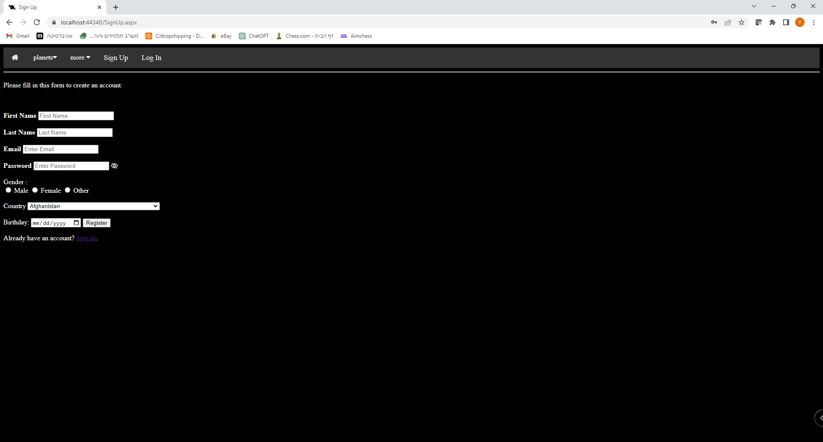

## **דף פרופיל אישי**

שם קובץ: UserPage.aspx

Aspx code:

<%@ Page Title="" Language="C#" MasterPageFile="~/Site1.Master" AutoEventWireup="true" CodeBehind="UserPage.aspx.cs" Inherits="ThePlanets.UserPage" %>

<asp:Content ID="Content1" ContentPlaceHolderID="head" runat="server">

<title><% Response.Write(Session["user"].ToString()); %>'s profile</title>

</asp:Content>

<asp:Content ID="Content2" ContentPlaceHolderID="ContentPlaceHolder1" runat="server">

<h1>Hello <% Response.Write(Session["user"].ToString()); %>!</h1>

<h1><a href="Update.aspx">Update</a></h1>

<h1><a href="login.aspx">log out</a></h1>

</asp:Content>

C# code:

using System;

using System.Collections.Generic;

using System.Linq;

using System.Web;

using System.Web.UI;

using System.Web.UI.WebControls;

namespace ThePlanets

{

public partial class UserPage : System.Web.UI.Page

{

protected void Page_Load(object sender, EventArgs e)

{

// For security

if (Session["user"] == null)

{

Response.Redirect("login.aspx");

}

}

}

}

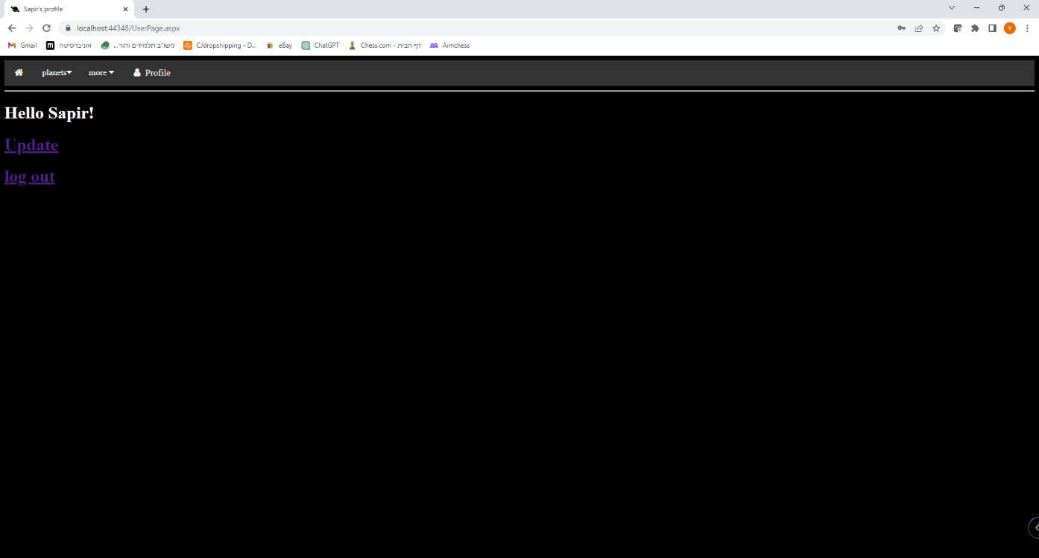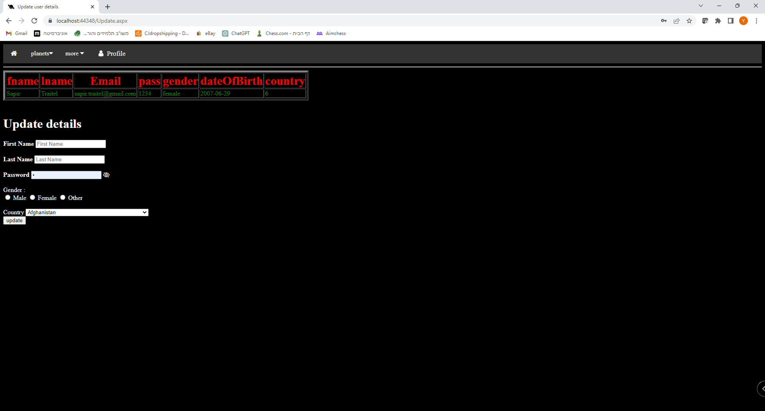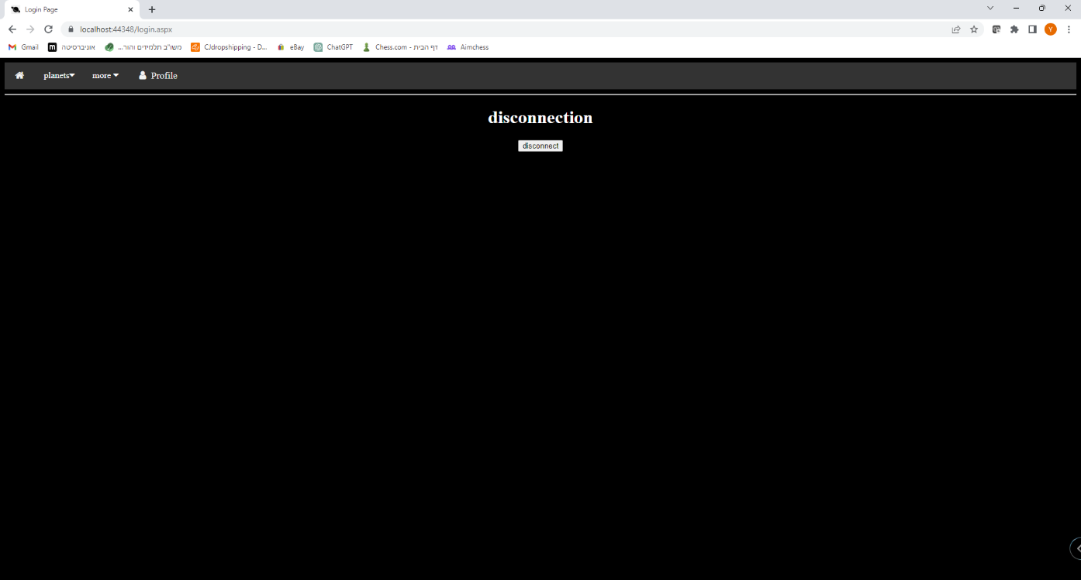

## **ניהול האתר**

שם קובץ: AdminPage.aspx

Aspx code:

<%@ Page Title="" Language="C#" MasterPageFile="~/Site1.Master" AutoEventWireup="true" CodeBehind="AdminPage.aspx.cs" Inherits="ThePlanets.AdminPage" %>

<asp:Content ID="Content1" ContentPlaceHolderID="head" runat="server">

<title>Administrator Page</title>

</asp:Content>

<asp:Content ID="Content2" ContentPlaceHolderID="ContentPlaceHolder1" runat="server">

<h1>hello administrator</h1>

<center>

<h1>DB</h1>

<% Response.Write(usersList); %>

<h1>filter DB</h1>

<form action="AdminPage.aspx" method="post">

<select name="field">

<option value="fname">First Name</option>

<option value="lname">Last Name</option>

<option value="Email">Email</option>

<option value="pass">Password</option>

<option value="gender">Gender</option>

<option value="dateOfBirth">dateOfBirth</option>

<option value="country">country</option>

</select>

<input type="text" name="fieldValue"/>

<input type="submit" name="filter" value="filter"/>

<br />

<input type="submit" name="fullDB" value="show full DB"/>

</form>

<h1>delete users in DB</h1>

<form action="AdminPage.aspx" method="post">

<h4>Delete according to fname:</h4><input type="text" name="userNameD"/>

<input type="submit" name="delete" value="Delete user"/>

</form>

</center>

<h1><a href="login.aspx">log out</a></h1>

</asp:Content>

C# code:

using System;

using System.Collections.Generic;

using System.Linq;

using System.Web;

using System.Web.UI;

using System.Web.UI.WebControls;

using System.Data;

namespace ThePlanets

{

public partial class AdminPage : System.Web.UI.Page

{

public string usersList = "";

protected void Page_Load(object sender, EventArgs e)

{

// For security

if (Session["admin"] == null)

{

Response.Redirect("login.aspx");

}

// If the admin wants to delete a user on the database

if (Request.Form["delete"] != null)

{

string userName = Request.Form["userNameD"];

string sql1 = String.Format("DELETE FROM usersTBL WHERE fname='{0}'", userName);

MyAdoHelper.DoQuery("Database.accdb", sql1);

}

string sql = "SELECT * FROM usersTBL";

// Filter the database according a field and a value

if (Request.Form["filter"] != null)

{

string field = Request.Form["field"];

string value = Request.Form["fieldValue"];

if (value != null)

{

sql = String.Format("SELECT * FROM usersTBL WHERE {0}='{1}'", field, value);

}

}

// If the admin want to see the whole database

if (Request.Form["fullDB"] != null)

{

sql = "SELECT * FROM usersTBL";

}

DataTable Dtable = MyAdoHelper.ExecuteDataTable("Database.accdb", sql);

// Presenting the database according a sql scentence

int length = Dtable.Rows.Count;

if (length > 0)

{

usersList += "<table border='5' style='color:Green;text-align:centerl;' >";

usersList += "<tr style='color:Red; font-size:30px;text-align:center;' >";

usersList += "<th>fname</th>";

usersList += "<th>lname</th>";

usersList += "<th>Email</th>";

usersList += "<th>pass</th>";

usersList += "<th>gender</th>";

usersList += "<th>dateOfBirth</th>";

usersList += "<th>country</th>";

usersList += "</tr>";

for (int i = 0; i < length; i++)

{

if (Dtable.Rows[i]["fname"].ToString() == "admin")

{

usersList += "<tr style='color: yellow; font-weight: bolder;'>";

usersList += "<td>" + Dtable.Rows[i]["fname"] + "</td>";

usersList += "<td>" + Dtable.Rows[i]["lname"] + "</td>";

usersList += "<td>" + Dtable.Rows[i]["Email"] + "</td>";

usersList += "<td>" + Dtable.Rows[i]["pass"] + "</td>";

usersList += "<td>" + Dtable.Rows[i]["gender"] + "</td>";

usersList += "<td>" + Dtable.Rows[i]["dateOfBirth"] + "</td>";

usersList += "<td>" + Dtable.Rows[i]["country"] + "</td>";

usersList += "</tr>";

}else

{

usersList += "<tr>";

usersList += "<td>" + Dtable.Rows[i]["fname"] + "</td>";

usersList += "<td>" + Dtable.Rows[i]["lname"] + "</td>";

usersList += "<td>" + Dtable.Rows[i]["Email"] + "</td>";

usersList += "<td>" + Dtable.Rows[i]["pass"] + "</td>";

usersList += "<td>" + Dtable.Rows[i]["gender"] + "</td>";

usersList += "<td>" + Dtable.Rows[i]["dateOfBirth"] + "</td>";

usersList += "<td>" + Dtable.Rows[i]["country"] + "</td>";

usersList += "</tr>";

}

}

usersList += "</table>";

}

}

}

}

